1. **HOME:-**

This section will redirect to the Home page of our editor.

The main page which will be opened first.

**6. CONTENT & IMAGES:-**

We are planning to place 2 small columns in the home page:

1. It’s Easy: [IMAGE]

-----------------------------

-----------------------------

-----------------------------

1. It’s Fast: [IMAGE]

-----------------------------

-----------------------------

-----------------------------

What is Photo Editing?(in the middle of the page)

-----------------------------

-----------------------------

-----------------------------

**7. FEATURES ICON BAR:-**

We will make a horizontal bar with all the icons of the features which is supported by the editor.

(Detailed info. about this section will be covered in 18. Point onwards.)

**10. MY PHOTOS SECTION:-**

(This section is one of the most fascinating sections for me.)

This section will act like a **menu bar** for our editor,

Starting with an **icon of ADD(+)** in a **square box** whose size will be **enlarged** on mousehover. After clicking the icon a window will be popped up from the local computer and will be directed to C:\\ drive of the computer(the window will ask user to select an existing picture from the computer).

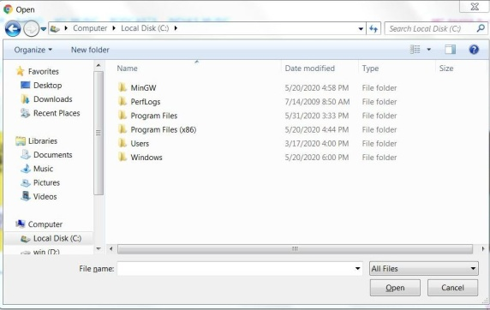

After this a **URL box** in which user can place url of the picture and the editor will **automatically download** the picture for the user(if possible…) and the picture will be available in the workspace.

After this **TABS Section**… User can open **multiple images at a time**(in-short user can edit multiple images at a time and all the images will be in different tabs with the same UI all the changes in different tabs will be saved differently.)(if we can do, we will place a small icon of the photograph selected on each tab in the tabs section…so that user can get an idea of where is the respective image.)(adding to this if the mouse will be hovered on the tab the ongoing process, workspace of the respective tab will be enlarged so that the user can have a look of his image which is open in a different tab…:-<https://medium.com/@9cv9official/create-a-beautiful-hover-triggered-expandable-sidebar-with-simple-html-css-and-javascript-9f5f80a908d1>)(or else we can do this:- <https://www.w3schools.com/howto/howto_js_hover_tabs.asp>)

**11. SAVE:-**

In the menu bar of our editor we will place a save option in a box at the end of the menu bar which will be enlarged on mousehover.

After save option is clicked a window will be popped asking user where to save the image….whose default position will be C:\\ drive….

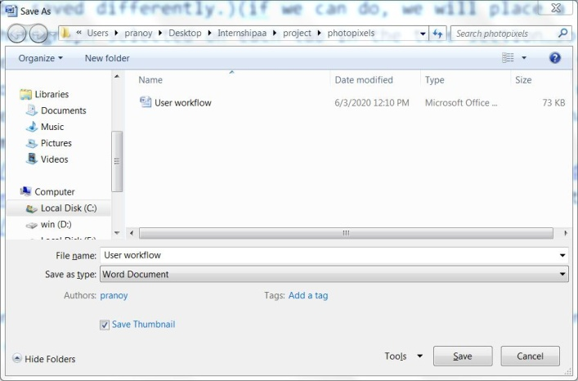

**12. NAME OF CURRENT TOOL OR OPTIONS AVAILABLE IN CURRENT TOOL:-**

Right under the **menu bar** we will place our **toolbar** … **name of the current tool** will be displayed in the **left** and following that if the **tool offer some properties** then those properties will be **placed after name of tool** and in the **icon format** and when those properties will be hovered then there name will be **popped** up….(eg. Selection an icon from Icon toolbar, say rotate…so in our toolbar…..

[Rotate (icon){rotate left} (icon){rotate right} and so on…..])

**13. GOOGLE SEARCH BOX:-**

A **google search box** will be placed just **after the toolbar ends**….this feature will **help user to search for images** of the respective query and after entering the query a **new tab** in the browser will be opened and with the **Image search results** of the query(after that user can either download the picture or else user can copy the url and place it in the url box of our editor).

**14. VERTICAL ICON BAR:-**

We have some articles to be referred for icons.

Our idea is we will **download** the images of all the **icons** we need and then make a **class of icons** and in the css file we will **specify the properties** of the class (eg:- the **colour** of the icons;;**{standard for all},** **size** of icons{standard})

As of now we don’t know **how to place the icon bar vertically/horizontally** in a rectangular box…..

**15. WORKSPACE:-**

We want that the **editing tool** whichever, is selected for editing **remains active only** in the workspace area…outside this workspace our **cursor** will be back in action.

All the editing will be done in the workspace section. The image selected from add icon or by url will be automatically placed in our workspace area.

**16. ACTIONS:-**

A rectangular box with a heading of **actions**.

Two options **UNDO(ICON);;REDO(ICON)** available in this box, then in the remaining area of the box we will place the **last 5 actions** performed by the user (eg. First user cropped then applied blur then rotated ….these actions will be saved in a stack and will be shown to user as his past 5 actions.)